Task 1: Create a Basic RESTful API
Use Express.js to implement the following endpoints for managing student records
Please find all the code in the ‘app’ folder. The database is in ‘app\db’ folder. Below screenshot demonstrates the setup of express.js and connection to SQLite database.
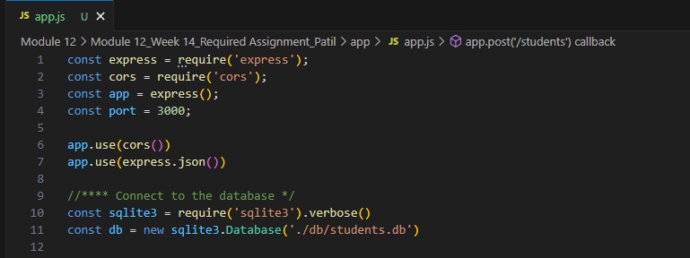
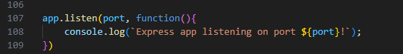

- GET /students: Retrieve a list of all students.
Below screenshot from app\app.js shows the ‘GET’ endpoint to retrieve the list of all student records.
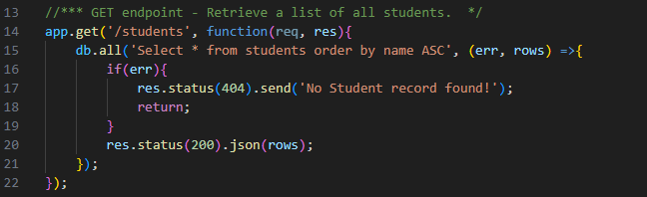

- GET /students/:id: Retrieve a specific student by its ID.
Below screenshot from app\app.js shows the ‘GET’ endpoint to retrieve the student record by id.
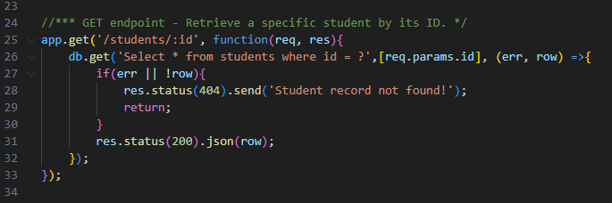

- POST /students: Add a new student.
Below screenshot from app\app.js shows the ‘POST’ endpoint to insert a record for new student into database.
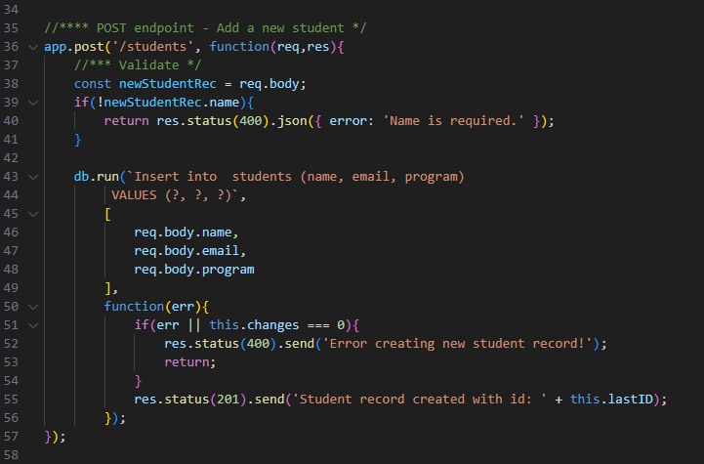

- PUT /students/:id: Update an existing student.
Below screenshot from app\app.js shows the ‘PUT’ endpoint to update a record of existing student by id.
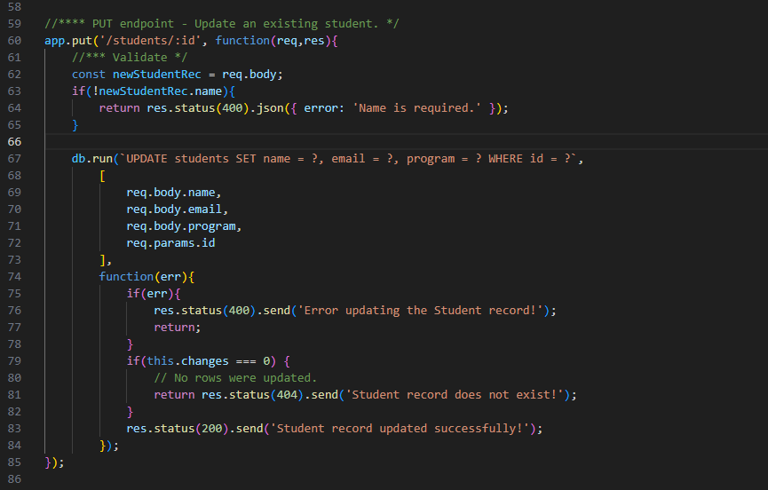

- DELETE /students/:id: Delete a student record.
Below screenshot from app\app.js shows the ‘DELETE’ endpoint to delete a record of existing student by id.
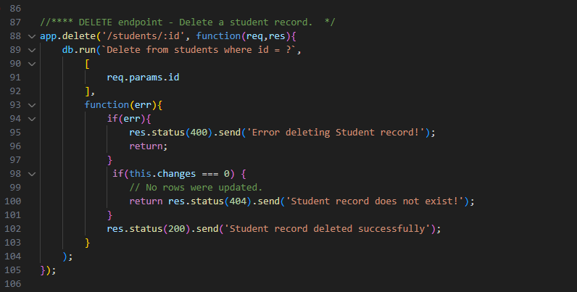

Task 2: Test the API with Postman
Please find below verification of endpoints done using Postman.
- Verify GET /students: Retrieve a list of all students.
Below screenshot shows all the student records are fetched and status code is 200.
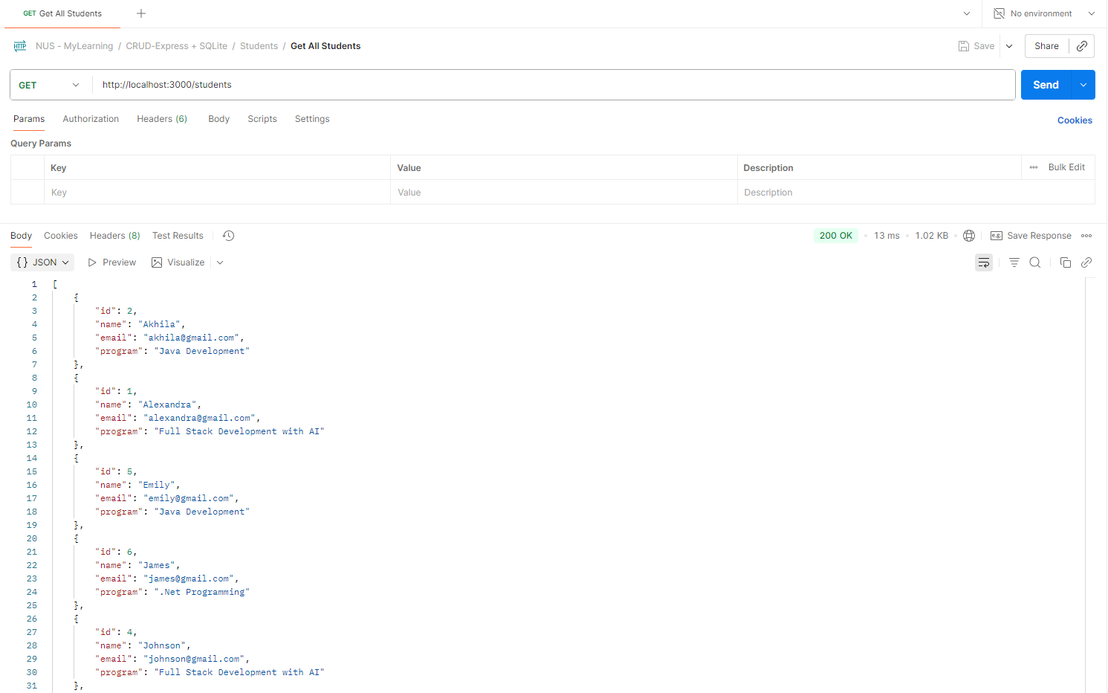

- Verify GET /students/:id: Retrieve a specific student by its ID.
Below screenshot shows the student record is retrieved correctly using id. The status code is 200.
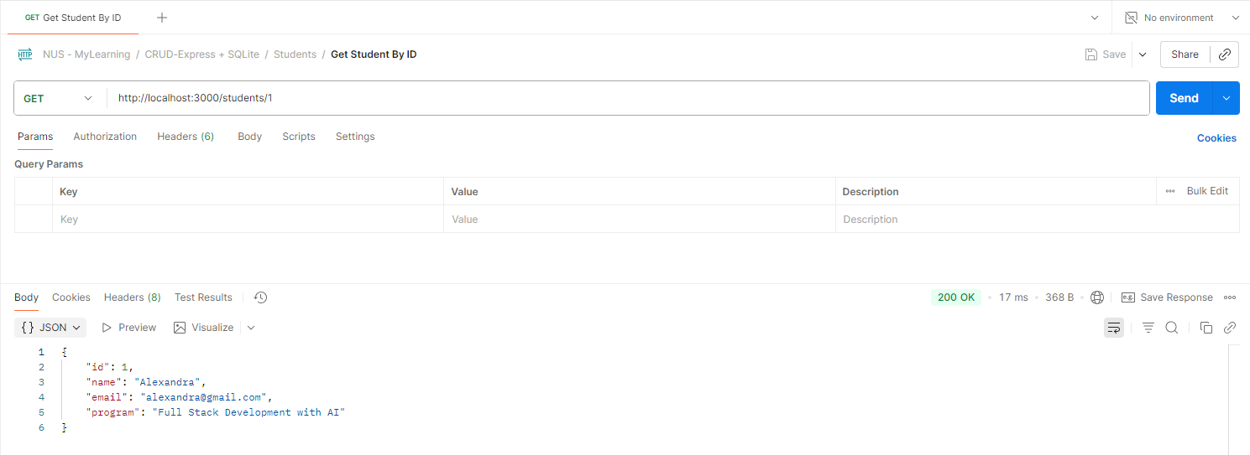

Below screenshot shows, the student record with id=101 does not exist. The status code returned is 404.
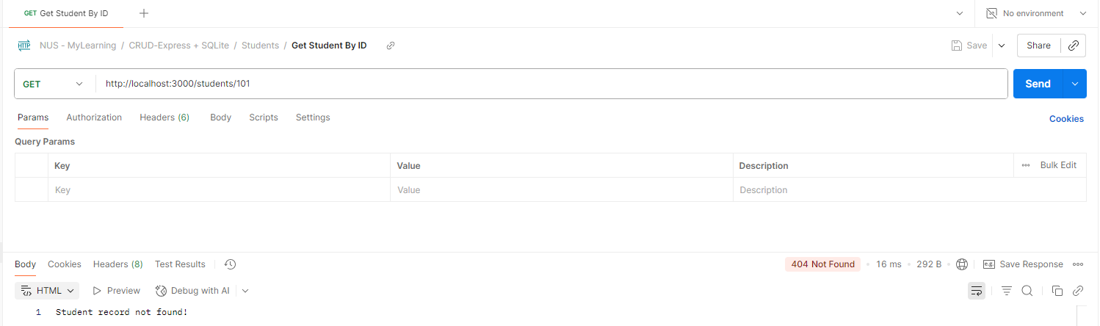

- Verify POST /students: Add a new student.
Below screenshot shows, the new Student record is added successfully. The status code returned is 201.
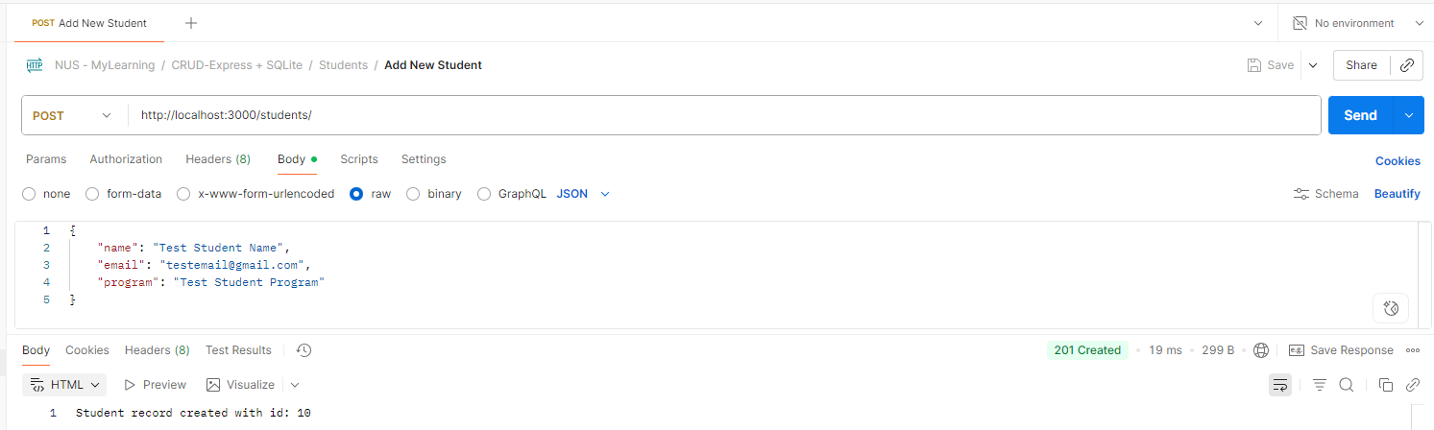

The below screenshot shows the API returned status code 400, as the required value for ‘name’ field is not provided.
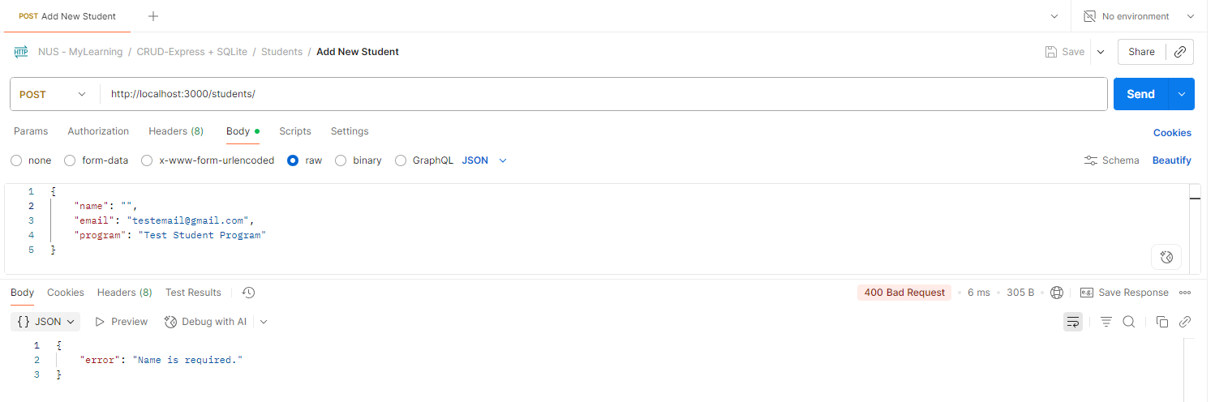

- Verify PUT /students/:id: Update an existing student.
Below screenshot shows, the Student record is updated successfully. The status code returned is 200.
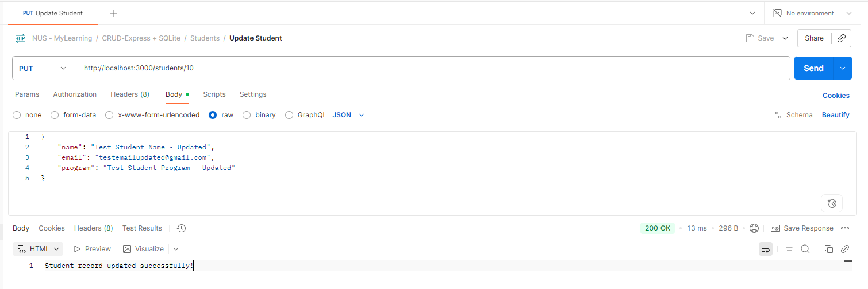

Use GET method by id to verify the changes saved to database.
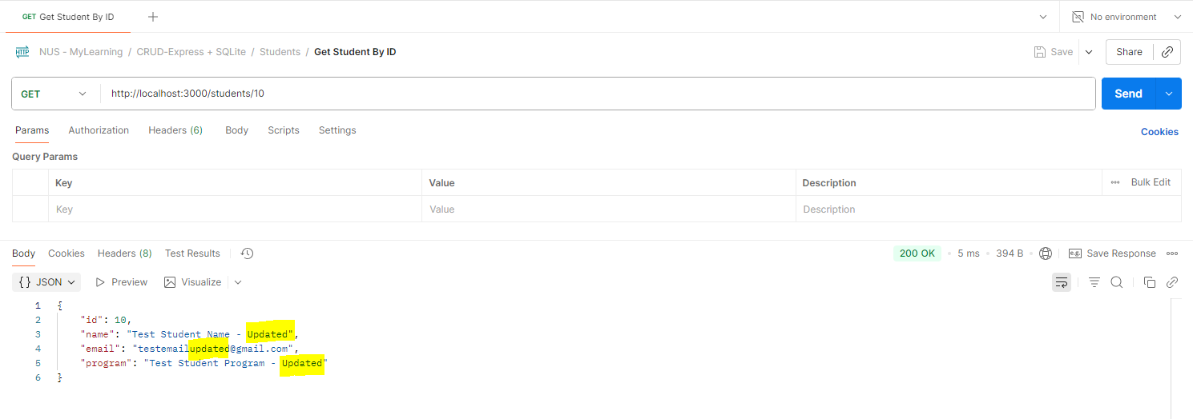

- Verify DELETE /students/:id: Delete a student record.
Below screenshot shows, the Student record is deleted successfully. The status code returned is 200.
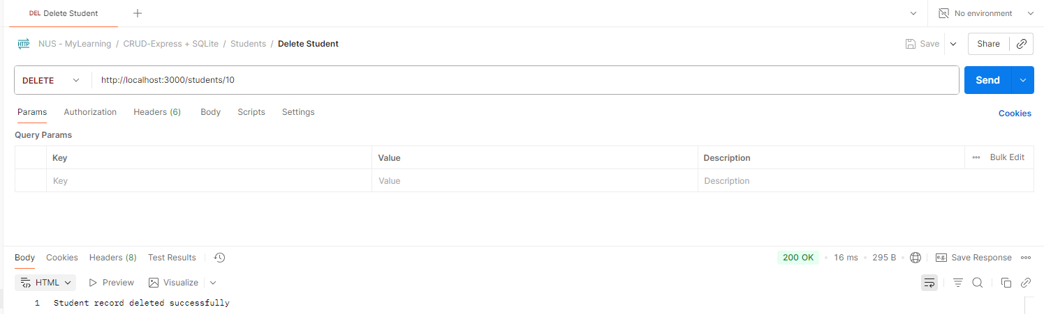

Use GET method by id to verify that the record is deleted and does not exist in database. The API returns status code 404 (Not found).
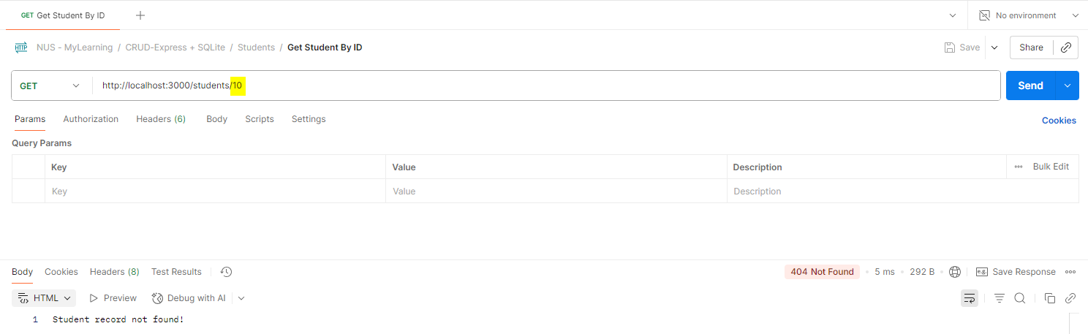

Task 3: Error Handling and Input Validation
- If a student record is not found in the GET, PUT, or DELETE requests, return a 404 Not Found response.
- Below screenshot shows that status code 404 is returned when student record is not found in GET request.
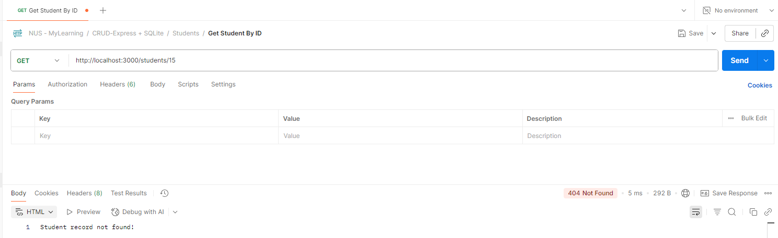

- Below screenshot shows that status code 404 is returned when student record is not found, in PUT request.
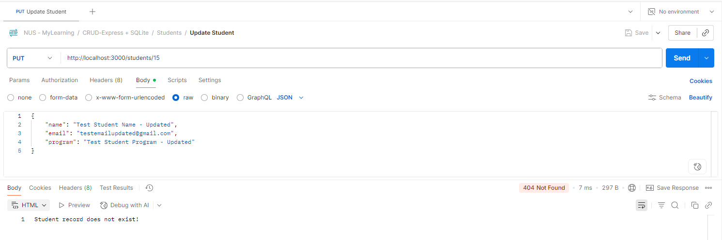
- Below screenshot shows that status code 404 is returned when student record is not found, in DELETE request.
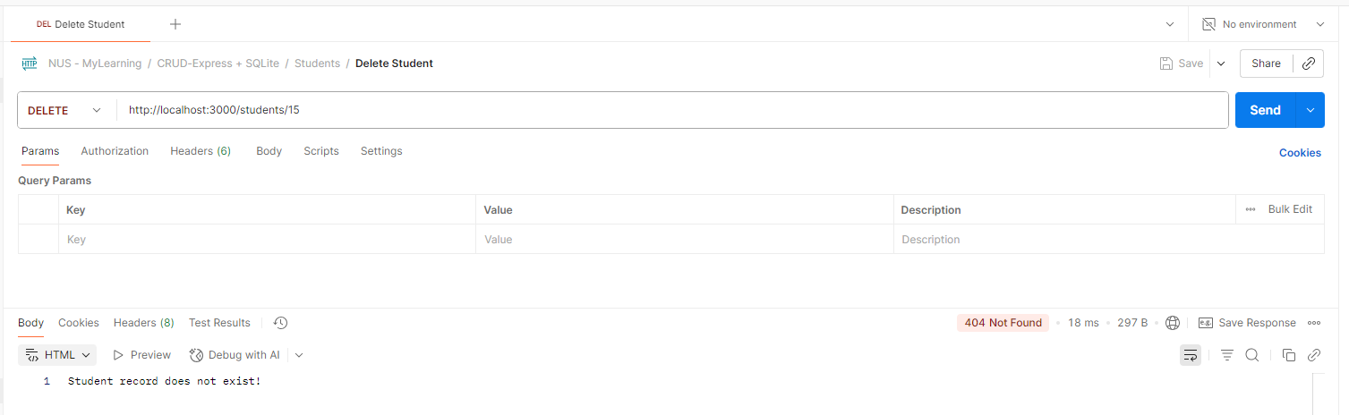

- If invalid data is sent in the POST or PUT requests, return a 400 Bad Request response.
- Below screenshot shows, the status code 400 (Bad Request) is returned from the POST request, when the required field name is not provided.
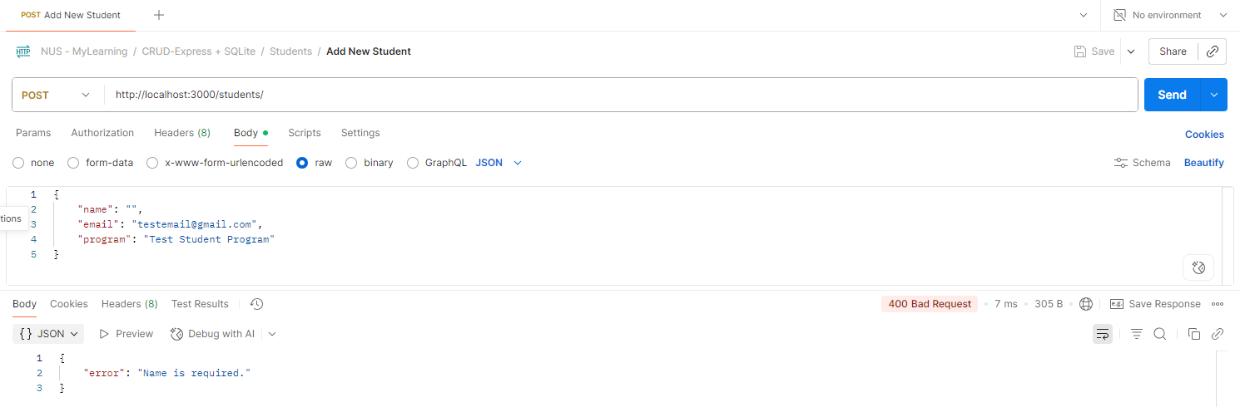

- Below screenshot shows, the status code 400 (Bad Request) is returned from the PUT request, when the required field name is not provided.
